**IFT 466 Advanced Computer Networks**

**Lab 29  
WAN - Researching WAN Technologies**

**Objectives**

Investigate Dedicated WAN Technologies and Providers

**Investigate Dedicated WAN Technologies and Providers**

In Part 1, you will research basic characteristics of dedicated WAN technologies, and in Part 2, you will discover providers that offer dedicated WAN services.

**Part 1: Research WAN technology characteristics.**

Use search engines and websites to research the following WAN technologies to complete the table below

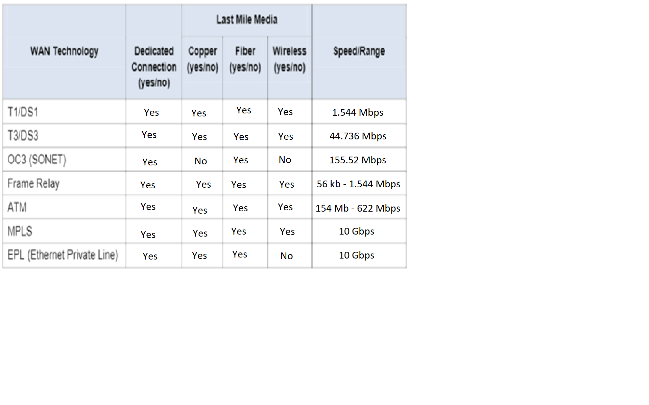

**Part 2: Discover dedicated WAN technology service providers.**

Navigate [https://www.telarus.com/suppliers/#](https://www.telarus.com/suppliers/). This webpage lists the Internet service provides that partner with Telarus to provide automated real-time telecom pricing.

Click the links to the various services offered.

Complete the table below by identifying each service provider’s dedicated WAN services, based on the information provided on the website. Use the extra lines provided in the table to record additional service providers.

